主题：水循环

题型：流程图

The diagram below shows the water cycle, which is the continuous movement of water on, above and below the surface of the Earth.

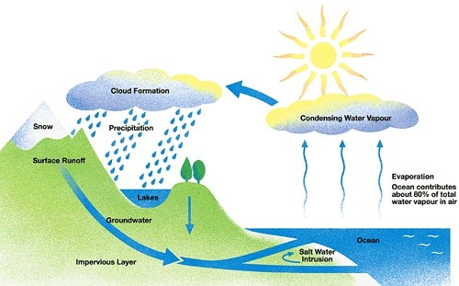

满分范文：  
The picture illustrates the way in which water passes from ocean to air to land during the natural process known as the water cycle.  
Three main stages are shown on the diagram. Ocean water evaporates, falls as rain, and eventually runs back into the oceans again.  
Beginning at the evaporation stage, we can see that 80% of water vapour in the air comes from the oceans. Heat from the sun causes water to evaporate, and water vapour condenses to form clouds. At the second stage, labelled ‘precipitation’ on the diagram, water falls as rain or snow.  
At the third stage in the cycle, rainwater may take various paths. Some of it may fall into lakes or return to the oceans via ‘surface runoff’. Otherwise, rainwater may filter through the ground, reaching the impervious layer of the earth. Salt water intrusion is shown to take place just before groundwater passes into the oceans to complete the cycle.